**BIGBANG ANGULAR PROJECT**

**DB SCHEMA:**

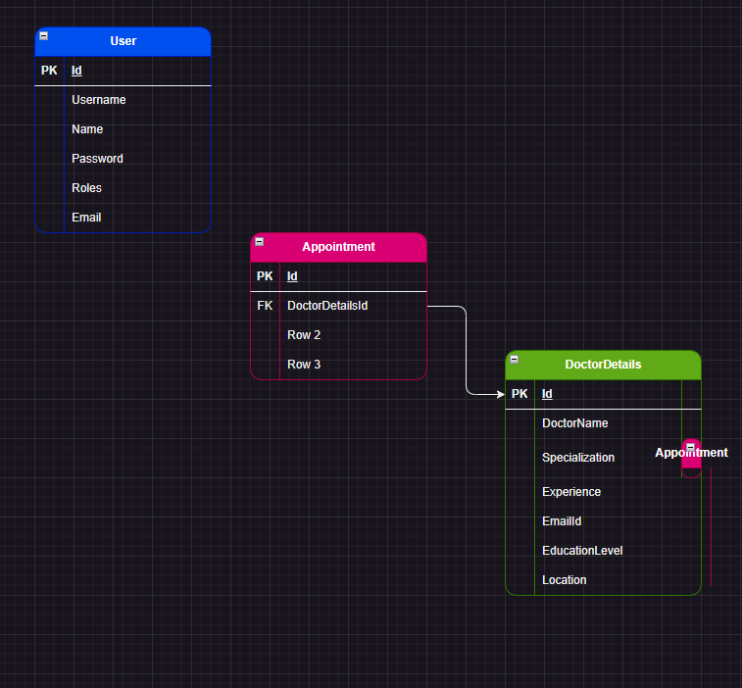

**3 FLOWS:**

**DOCTOR FLOW:**

CAN VIEW THE APPOINMENTS ALLOTTED FOR HIM

CAN VIEW HIS PROFILE AND HE CAN UPDATE HIS PROFILE

CAN SEND A REQUEST TO ADMIN TO LOGIN

**ADMIN FLOW:**

PREFORM CRUD OPERATION

CAN SEE ALL THE DOCTORS

Can Accept/Reject the request

CAN BOOK AN APPOUNTMENT

**USER FLOW:**

CAN BOOK AN APPOUNTMENT

CAN SEE ALL THE DOCTORS